**Layout varient**

1.Select the button_count Button in the **Component Tree**, and Shift-select the button_toast Button so that both are selected.

1. Click the pack button  in the toolbar, and choose **Expand Horizontally** as shown in the figure below.

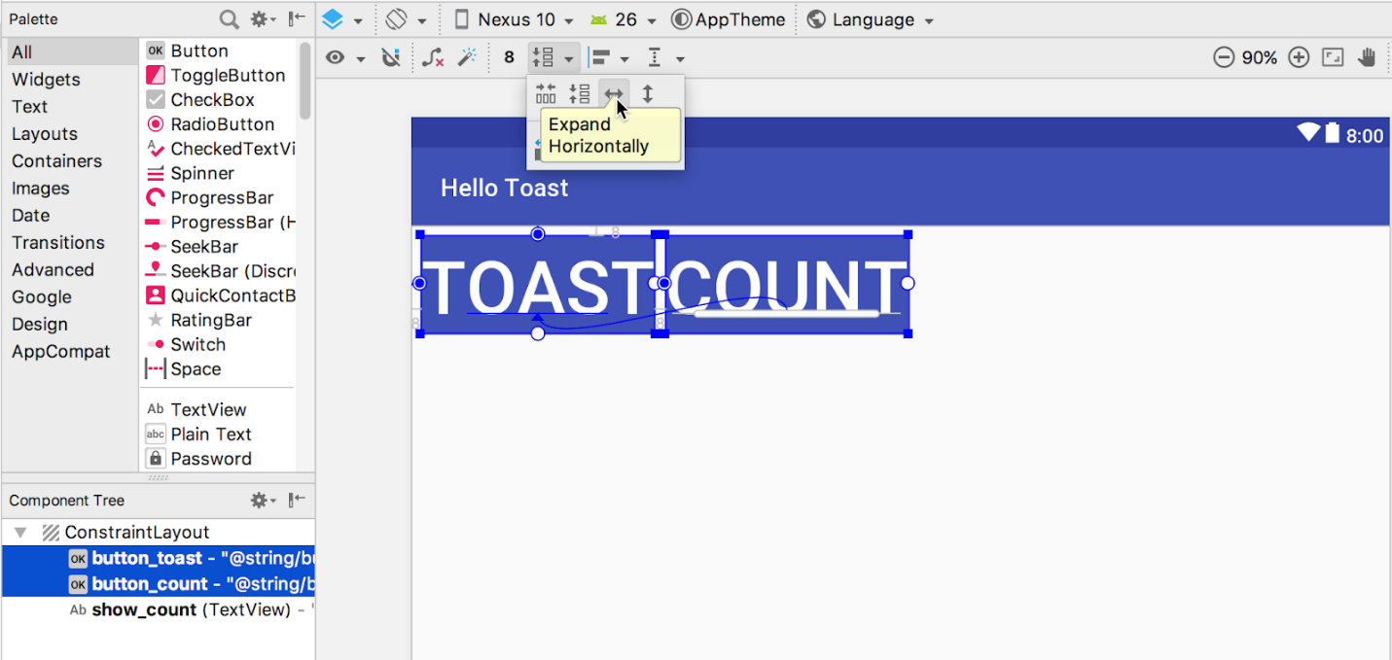

The Button elements expand horizontally to fill the layout as shown below.

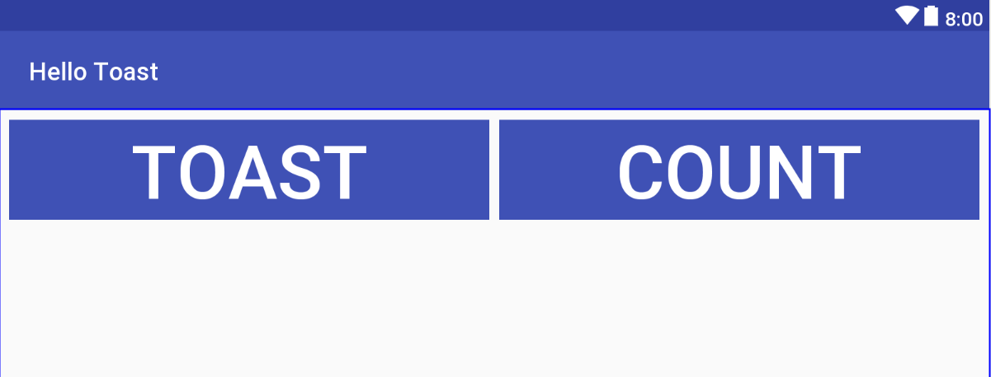

1. To finish the layout, constraint the show_count TextView to the bottom of the button_toast Button and to the sides and bottom of the layout, as shown in the animated figure below.



1. The final steps are to change the show_count TextView layout_width and layout_height to **Match Constraints** and the textSize to **200sp**. The final layout looks like the figure below.

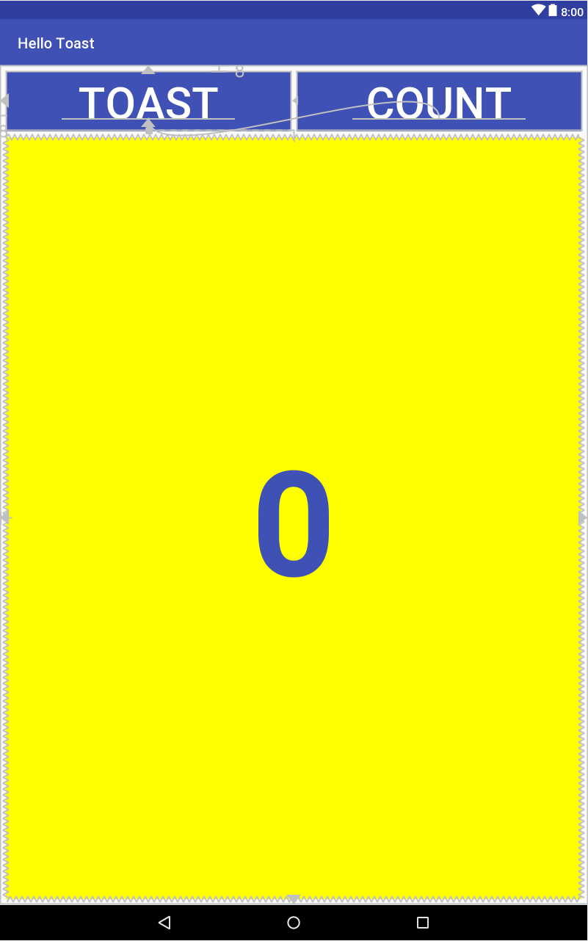

1. Click the **Orientation in Editor** button Orientation in Editor button in the top toolbar and choose **Switch to Landscape**. The tablet layout appears in horizontal orientation as shown below. (You can choose **Switch to Portrait** to return to vertical orientation.).

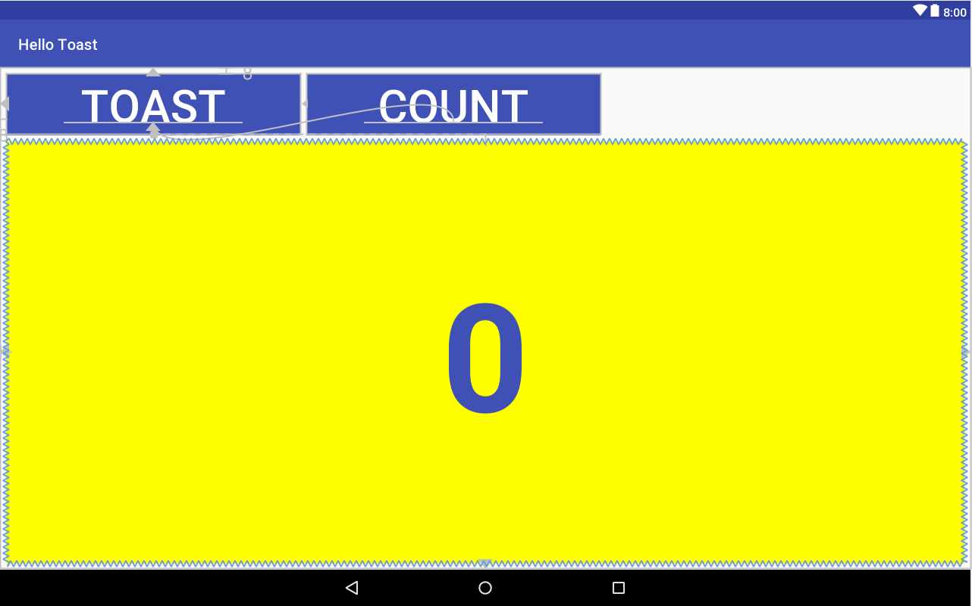

1. Run the app on different emulators, and change the orientation after running the app, to see how it looks on different types of devices. You have successfully created an app that can run with a proper UI on phones and tablets that have different screen sizes and densities.